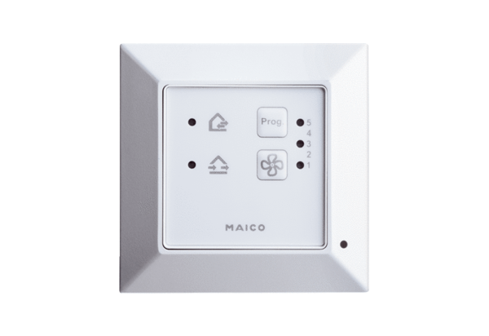Room air control RLS 45 OPacking unit: 1 pieceRange: K
Article number: 0157.0359Manufacturer: MAICO

