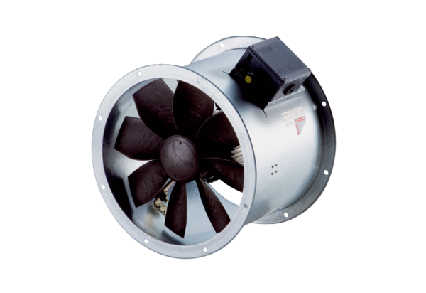Axial duct fan DZR 50/4 B Ex tPacking unit: 1 pieceRange: C
Article number: 0086.0734Manufacturer: MAICO

