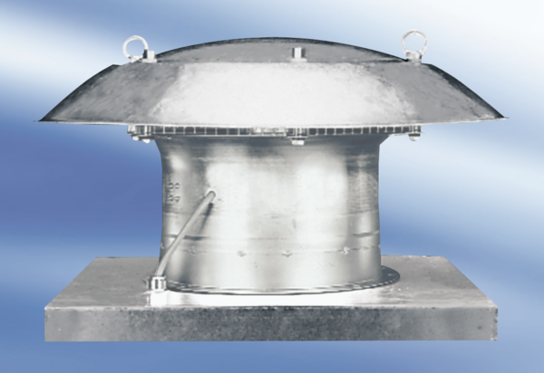Axial roof fan DZD30-4APacking unit: 1 pieceRange:
Article number: 0087.0415Manufacturer: MAICO

