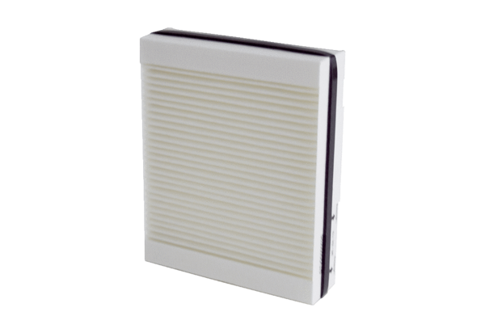Air filter, replacement Trio M5 LPacking unit: 1 pieceRange: K
Article number: 0093.1451Manufacturer: MAICO

