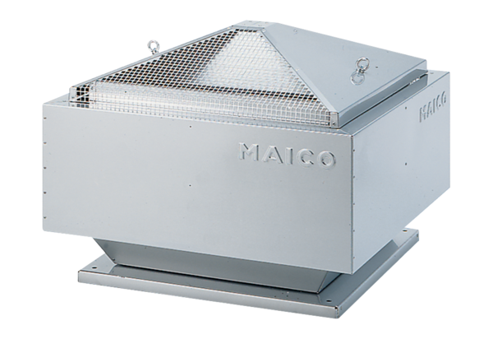Centrifugal roof fan DRD 35/6 BPacking unit: 1 pieceRange: C
Article number: 0087.0107Manufacturer: MAICO

