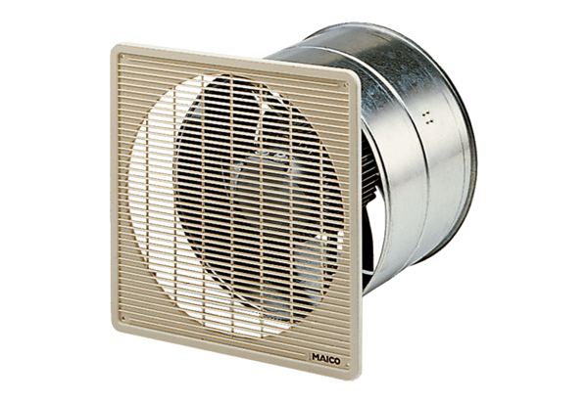Axial wall-mounted fan EZF 50/6 BPacking unit: 1 pieceRange: C
Article number: 0085.0062Manufacturer: MAICO

