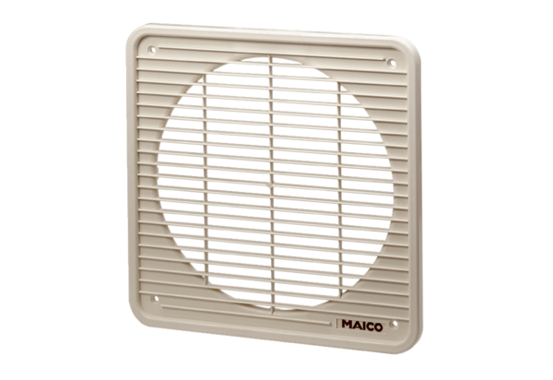Internal grille IG 40Packing unit: 1 pieceRange: C
Article number: 0059.0175Manufacturer: MAICO

