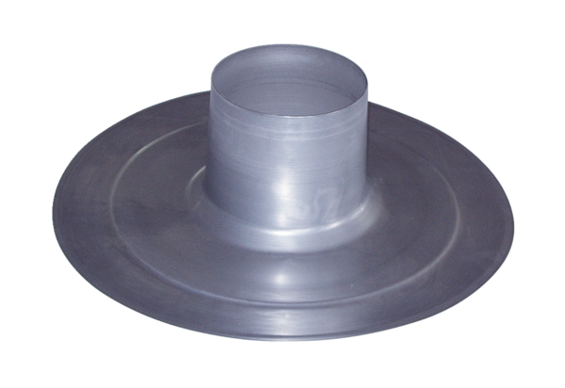Roofing tile DP 125 APacking unit: 1 pieceRange: B
Article number: 0092.0382Manufacturer: MAICO

