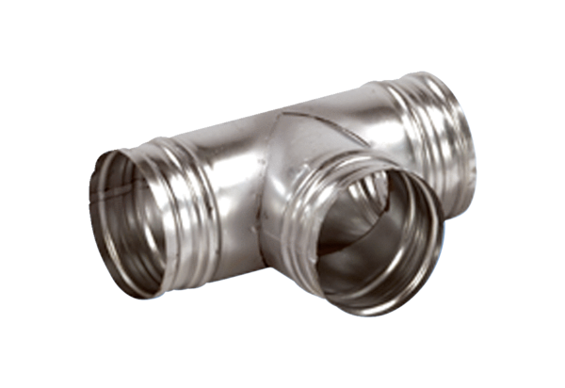90° branch AB 200-125Packing unit: 1 pieceRange: K
Article number: 0055.0383Manufacturer: MAICO

