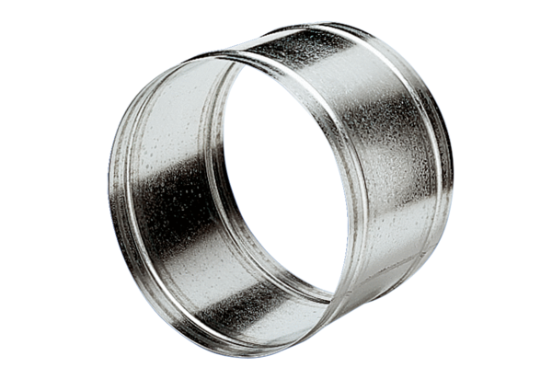Extension sleeve VH 30Packing unit: 1 pieceRange: C
Article number: 0055.0032Manufacturer: MAICO

