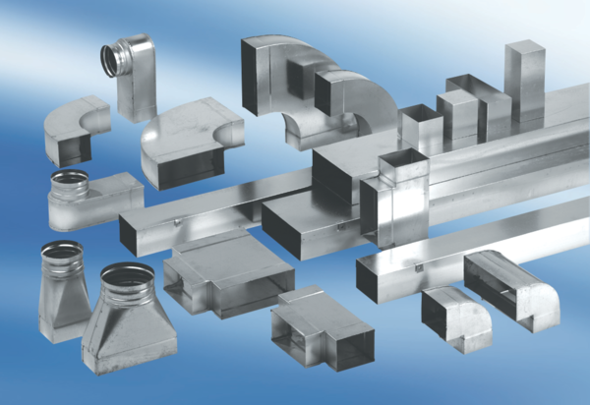90° channel elbows, short, horizontal KB90KH/55/110Packing unit: 1 pieceRange: K
Article number: 0055.0588Manufacturer: MAICO

