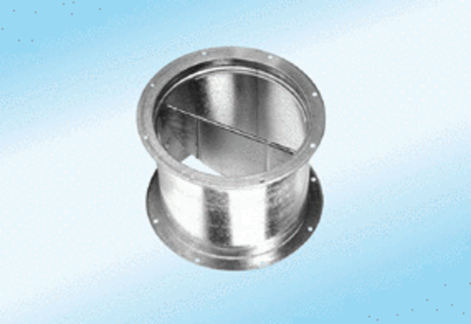Shutter, pull device VD 40-ExPacking unit: 1 pieceRange: C
Article number: 0093.0634Manufacturer: MAICO

