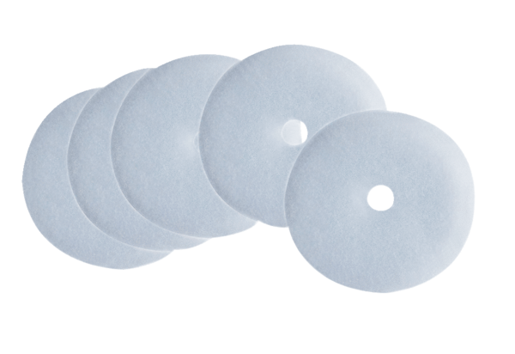Air filter, replacement ZF ECPacking unit: 5 piecesRange: B
Article number: 0093.0758Manufacturer: MAICO

