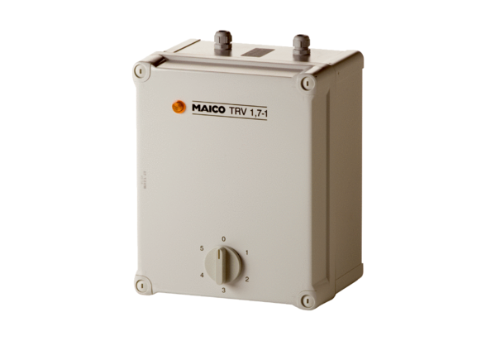5-step transformer TRV 1,7-1Packing unit: 1 pieceRange: C
Article number: 0157.0533Manufacturer: MAICO

