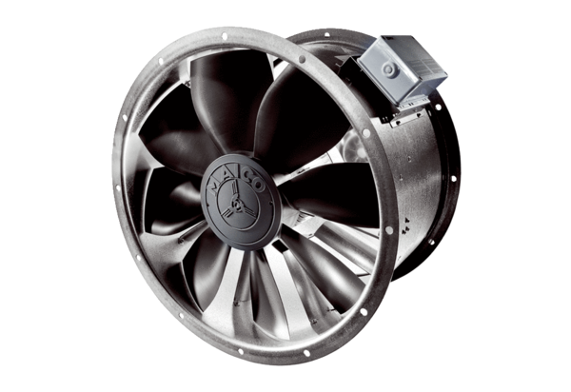Axial duct fan DZL 60/4 BPacking unit: 1 pieceRange: C
Article number: 0086.0092Manufacturer: MAICO

