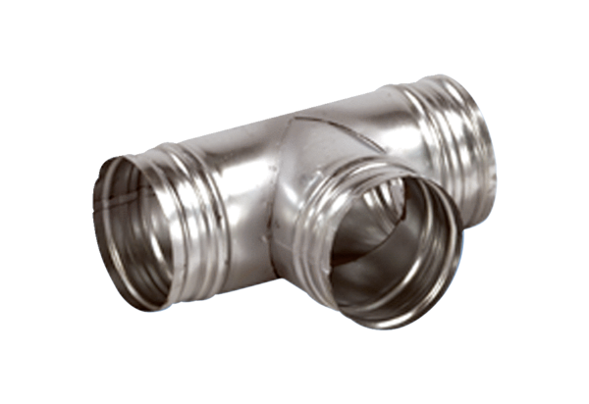90° branch AB 200-160Packing unit: 1 pieceRange: K
Article number: 0055.0385Manufacturer: MAICO

