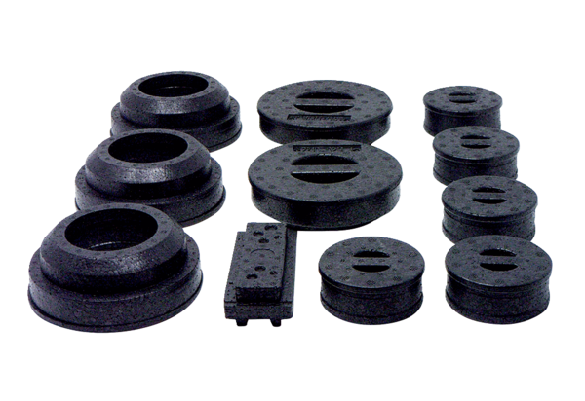Plug set WS 120 Trio SPacking unit: 1 pieceRange: K
Article number: 0058.0506Manufacturer: MAICO

