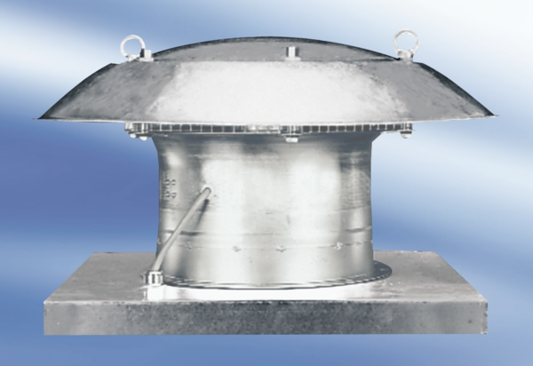Axial roof fan DZD 30/6 APacking unit: 1 pieceRange:
Article number: 0087.0414Manufacturer: MAICO

