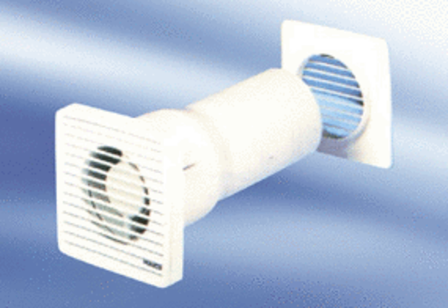Small room fan ECA 10-3Packing unit: 1 pieceRange:
Article number: 080027Manufacturer: MAICO

