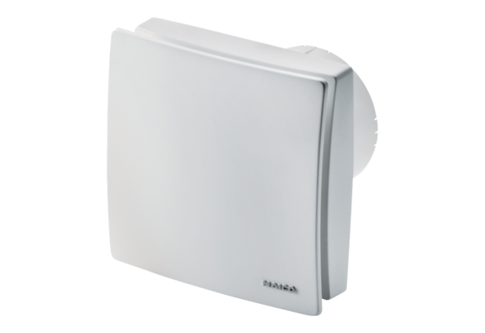Small room fan ECA 100 ipro RCPacking unit: 1 pieceRange: A
Article number: 0084.0210Manufacturer: MAICO

