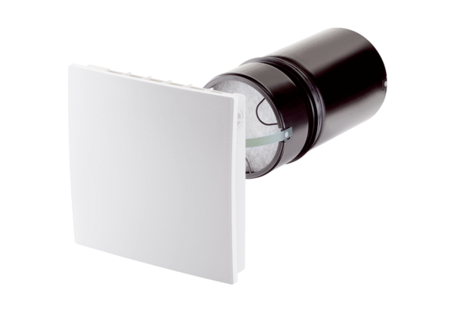Final assembly kit PP 45 OPacking unit: 1 pieceRange: K
Article number: 0095.0240Manufacturer: MAICO

