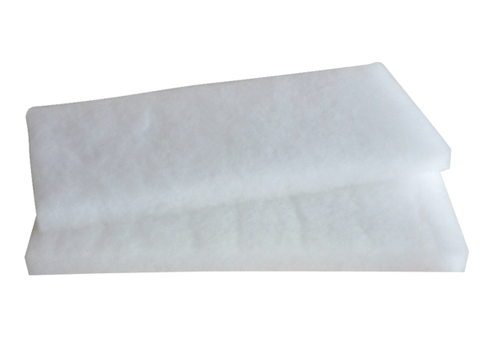Air filter, replacement WRF 180 ECPacking unit: 2 piecesRange: K
Article number: 0093.0060Manufacturer: MAICO

