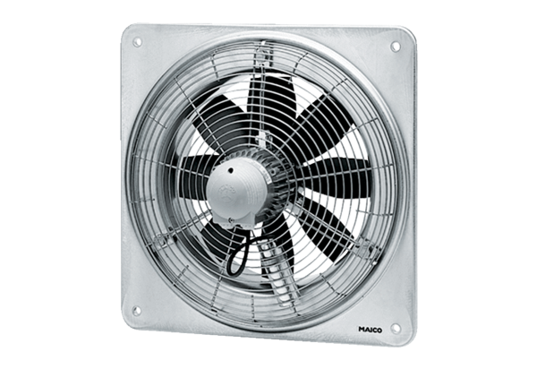Axial wall fan DZQ 20/2 BPacking unit: 1 pieceRange: C
Article number: 0083.0116Manufacturer: MAICO

