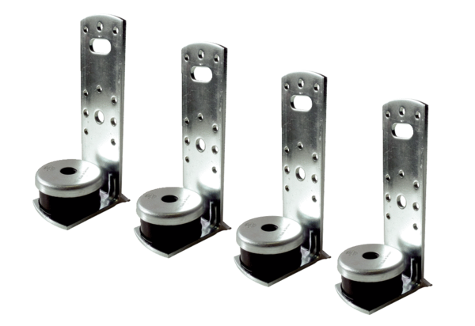Ceiling fixing bracket WS-BWD 160Packing unit: 4 piecesRange: K
Article number: 0092.0566Manufacturer: MAICO

