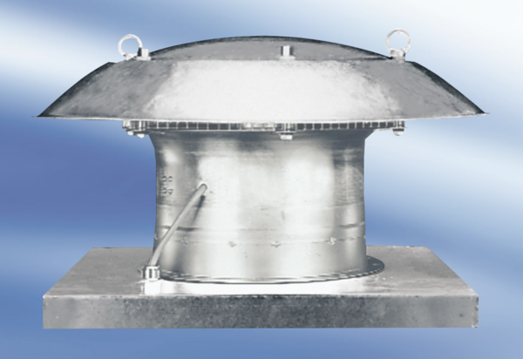Axial roof fan DZD 35/6 A-ExPacking unit: 1 pieceRange: C
Article number: 0087.0770Manufacturer: MAICO

