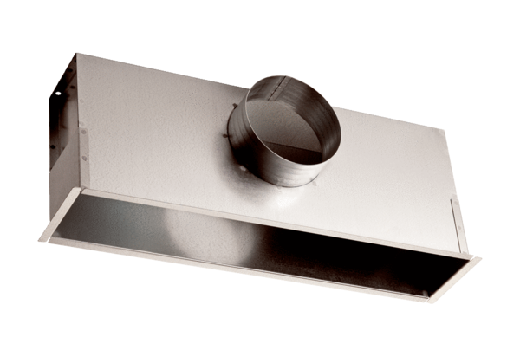Installation box EK 42/12Packing unit: 1 pieceRange: C
Article number: 0149.0084Manufacturer: MAICO

