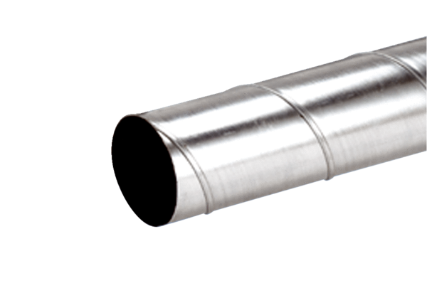Folded spiral-seams duct WFR 150Packing unit: 1 pieceRange: K
Article number: 0055.0078Manufacturer: MAICO

