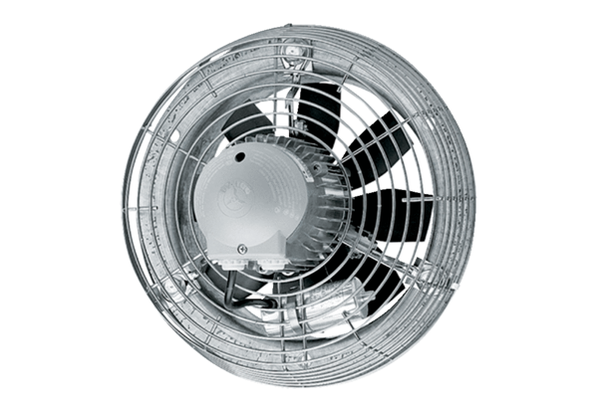Axial wall fan DZS 40/6 BPacking unit: 1 pieceRange: C
Article number: 0094.0021Manufacturer: MAICO

