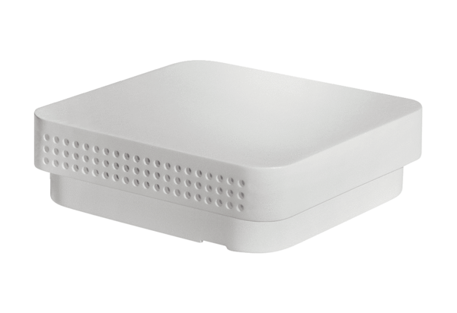Humidity and temperature sensor FFT 30 KPacking unit: 1 pieceRange: K
Article number: 0157.0121Manufacturer: MAICO

