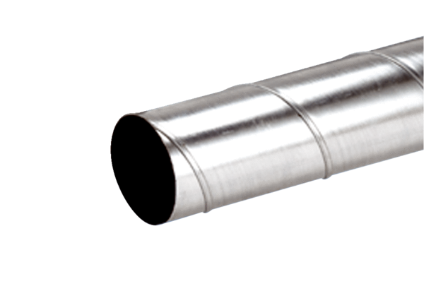Folded spiral-seams duct WFR 100Packing unit: 1 pieceRange: K
Article number: 0055.0076Manufacturer: MAICO

