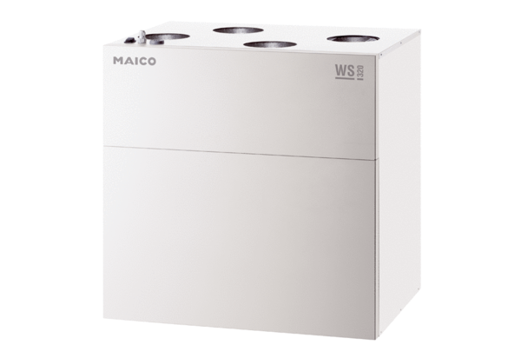Centralised ventilation unit WS 320 KPacking unit: 1 pieceRange: K
Article number: 0095.0222Manufacturer: MAICO

