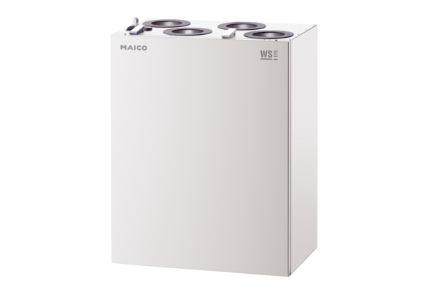Centralised ventilation unit WS 170 KRPacking unit: 1 pieceRange: K
Article number: 0095.0083Manufacturer: MAICO

