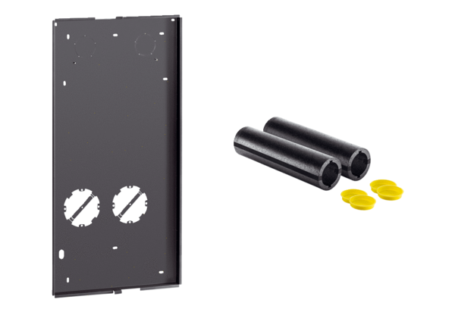shell installation kit WS 75 RSAPPacking unit: 1 pieceRange: K
Article number: 0093.1615Manufacturer: MAICO

