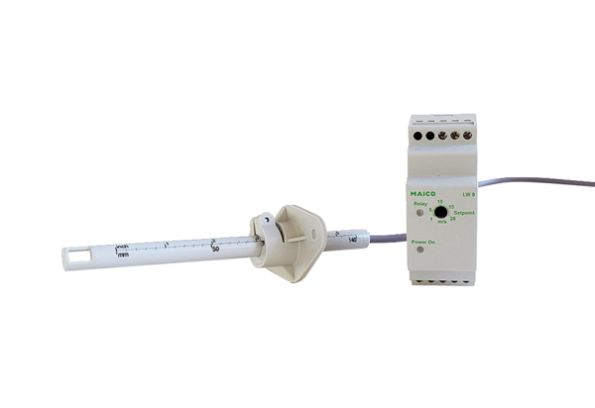Air flow monitor LW 9Packing unit: 1 pieceRange: D
Article number: 0157.0779Manufacturer: MAICO

