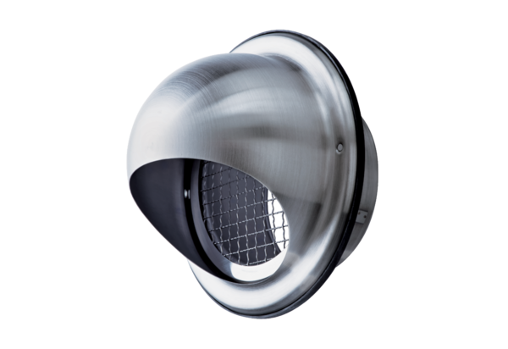Stainless steel cowl LH-V2A 10Packing unit: 1 pieceRange: C
Article number: 0151.0377Manufacturer: MAICO

