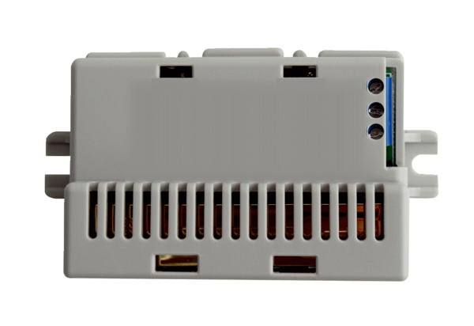CO2 sensor Trio CO2 IPacking unit: 1 pieceRange: K
Article number: 0157.1332Manufacturer: MAICO

