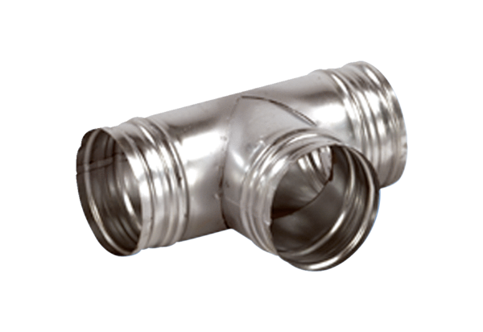90° branch AB 200-150Packing unit: 1 pieceRange: K
Article number: 0055.0384Manufacturer: MAICO

