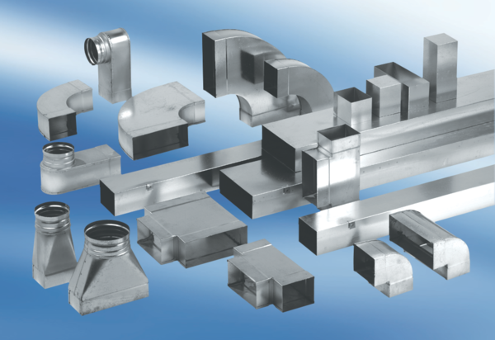Adaptor plug connector SVF80/200Packing unit: 1 pieceRange: K
Article number: 0055.0569Manufacturer: MAICO

