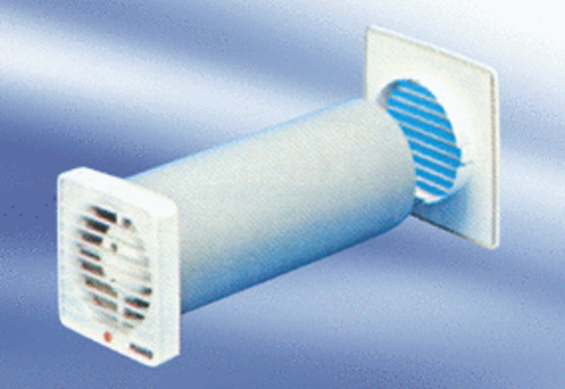Small room fan ECA 9-3 VZPacking unit: 1 pieceRange:
Article number: 080047Manufacturer: MAICO

