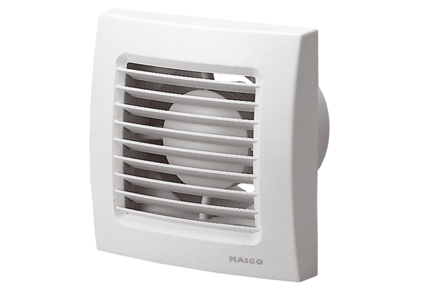Small room fan ECA 100 VZCPacking unit: 1 pieceRange: A
Article number: 0084.0040Manufacturer: MAICO

