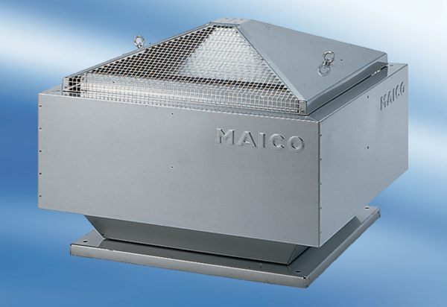Centrifugal roof fan DRD45-64Packing unit: 1 pieceRange:
Article number: 0087.0154Manufacturer: MAICO

