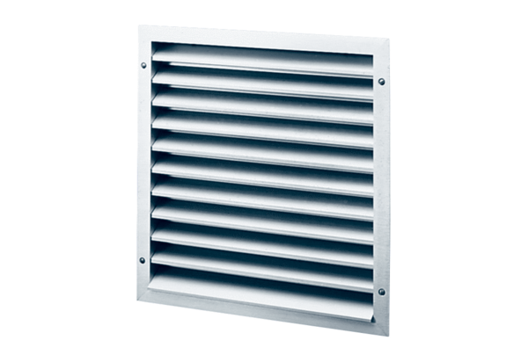External grille MLA 35Packing unit: 1 pieceRange: C
Article number: 0151.0114Manufacturer: MAICO

