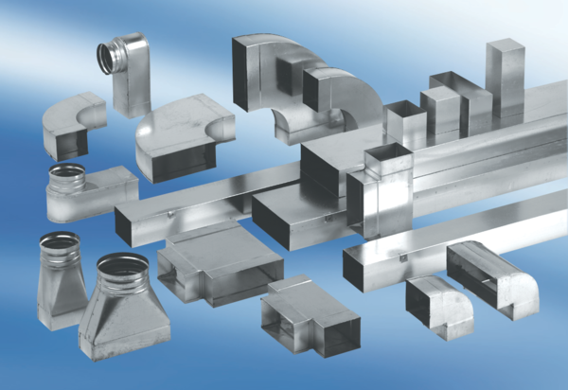Reducer, asymmetrical REDA55/220/80/2Packing unit: 1 pieceRange: K
Article number: 0055.0711Manufacturer: MAICO

