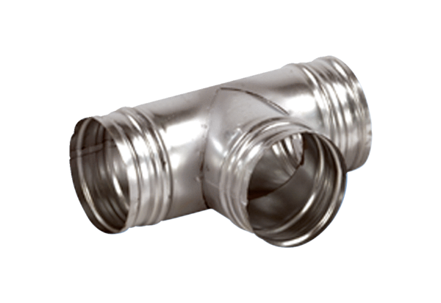90° branch AB 160-180Packing unit: 1 pieceRange: K
Article number: 0055.0372Manufacturer: MAICO

