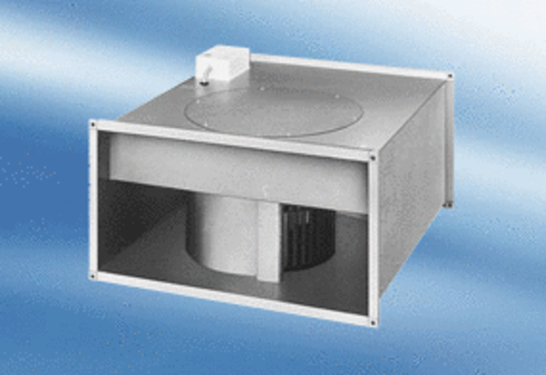Channel fan EPK 28/6 APacking unit: 1 pieceRange:
Article number: 0086.0614Manufacturer: MAICO

