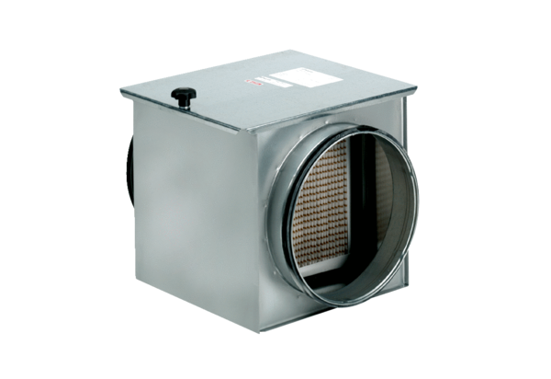Air filter TFE 31-7Packing unit: 1 pieceRange: C
Article number: 0149.0055Manufacturer: MAICO

