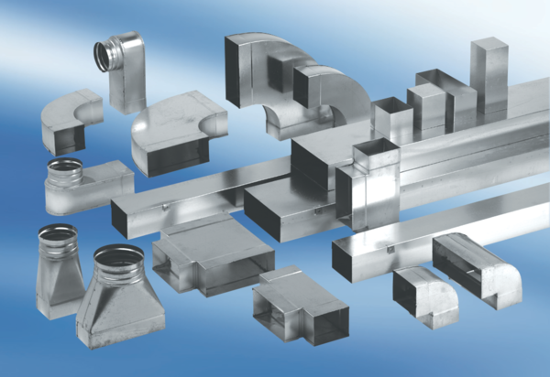90° angle elbow, symmetrical WB90SN/80/200/80Packing unit: 1 pieceRange: K
Article number: 0055.0619Manufacturer: MAICO

