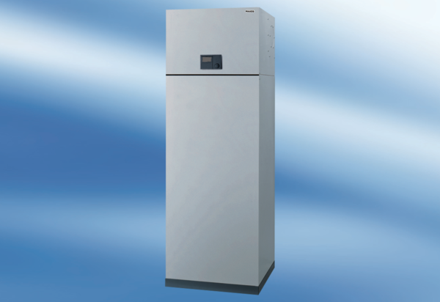Aeronom room air system AWP 150 SPacking unit: 1 pieceRange: K
Article number: 0095.0053Manufacturer: MAICO

