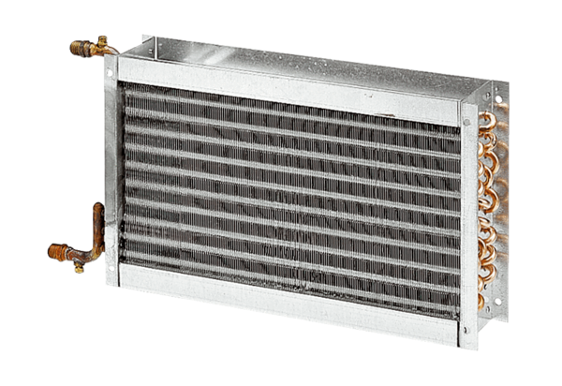Water air heater WHP 28-29Packing unit: 1 pieceRange: D
Article number: 0082.0113Manufacturer: MAICO

