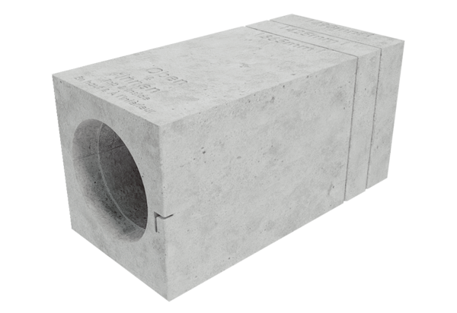Insulated wall block MS 160Packing unit: 1 pieceRange: K
Article number: 0058.0168Manufacturer: MAICO

